Curriculum Vitae

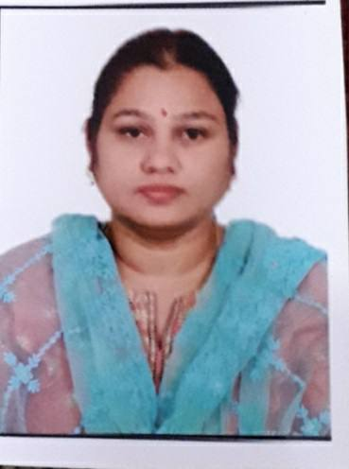

**Dr. VEENA RAPARTHI**

**Assistant Professor (PT)**

University College of Science,

Dept of Geography. Osmania University

Email : [veenaraparthi@gmail.com](mailto: veenaraparthi@gmail.com) Mobile : 8179386293,9550962662

**Office Home**

University college of science,

Dept of Geography. Osmania University

Flat no 303, Anvi Urban oaks 2, Hislop road, Prakruthikvihar, Yapral, Secunderabad -500010.

**Career Goal**

To extend my acquired education expertise towards all round development of students as a teaching professional.Aside from providing high-quality teaching, handle other duties and responsibilities as well. To Help students develop their skills and abilities, assist them in reaching their potential, and ensure the learning environment is appropriate and positive.

**Qualifications at a glance**

* More than Thirteen years of teaching experience at different levels in the field of education.
* More than 4 years of expertise in guiding research scholars to teaching post graduate students.
* Implemented various interpersonal expertise’s and contacted with organizations, guardians and number of students in creating better learning experiences through educational material and peer professionals.
* Possess a quality for adopting new concepts in the area of teaching as well as handling responsibilities.
* Able to accomplish immediate and long-term goals and also within operating deadlines.
* Achieved **Highest marks**, in M.SC-Geography at Osmania University for Academic Year 2001-2003
* Achieved **Zakia Sultana rolling shield award** for securing highest marks in Geography at University level during Graduation.

# Education

**M.Sc. Geography, Osmania University, 2003.**

**TS- SET Geography. 2019**

**Ph.D, Osmania University, 2020.**

# Work Experience

**Mar 2003-Dec 2005**

Worked with Navya Bharathi international school, Nizamabad.

**Mar 2005 – Nov 2006:**

Worked with Kings Field Primary School, Burnsfield street, Chatteris, Cambridge shire, Cambridge.UK.

**Jan 2006- Dec 2010:**

Worked in setting up Little Bells School, Nizamabad as a startup.

**April 2011 – June 2021:**

Working with Gitanjali group of schools,Secunderabad**.**

**July 2021 till date**

**Working at Dept of geography, University college of Science, Osmania University.**

# ResearchTopic:

### Dynamics of Urban growth and development. A Study of Telangana.:

### This paper maps out the structure and relative dynamics of cities of various size classes in Telangana. It aims to address their hierarchical distribution, by employing the rank-size rule, and a primacy index. The implications of urban concentrations for GDP, banking system, civic amenities, and various urban externalities (such as pollution and spatial exclusion) are also examined. It shows that Telangana’s urban system, though it follows the rank-size rule, is huge and top-heavy. Although Telangana cities collectively account for less than one third of the total population, they command more than three fourths of the State’s GDP. Megacities have become congested, clogged, polluted, and also show significant social polarization. There is a gridlock situation for the cities, inhibiting their potential for becoming effective economic and social change sites. The top-heavy character of Telangana’s urban system also adversely impacts the balanced regional development of the State.

### Publications:

### A Study on trends and challenges of urbanization and Urban development in Telangana state.

### Published in JETIR- UGC approved Journal. Published in Volume 6 issue 5, may 2019.

### Spatio Temporal Assessment of Urban Sprawl on Land use and Land cover changes in greater Hyderabad Region using Geoinformatics Technology.Published in Education and Society – UGC approved journal in Vol 47, No 3 July – December-2024

### Seminars Organized:

### Conducted and organized seminars and technical sessions in international conferences,

### 18th International conference of DGSI In collaboration with Dept of Geography, On Urbanization and climate change: Strategies for sustainable cities through Geospatial technologies.

### as a HOD , Dept of Geography . Gitanjali Devshala.

### 1. Induction Training for new teachers in Geography

### 2. Being a Firm Friendly & Approachable teacher

### 3. Re-vitalize your attitude – a refresher course

### 4. More than just a teacher- learning, balancing roles in life, teamwork, science of positive thinking.

### 5. Good health for better living ( physical, mental & emotional)

### 6. Identity, Institutional Pride & productivity

# Corporate/Administrative Experience

1. Life Member – Indian National Cartographic Association
2. Woman Counsellor- Interact Club (Rotary Club) Hyderabad.
3. Coordinating Officer, College DevelopmentCouncil.
4. Coordinating Officer -IIHM

# Trainings and Other Programs Attended

## COURSES:

1. Orientation course, Kingsfield School, sponsored by IGCSE. Cambridge shire. 2008.

2. Geography is all around us * - A course which helps teachers how geography is best learned through events, landmarks and experiences all around us.

3. CISCE-SCE- Integrating Gender Equality in Learning Process. A course conducted by council of Indian schools.,2nd October 2021.

## WORKSHOP & TRAINING:

1. One day workshop GNSS & its application on 19th October2016
2. Two days on national workshop on open source and mobile GIS. 21st & 22nd April2017
3. One day workshop on Teaching, Learning & Assessment Methodologies on 17th December2016
4. Attended one day state level forest nature camp. 21st January2018
5. Developing effective Facilitating Skills. Gitanjali Devshala. April, 2019
6. Conducting Effective Sessions. Gitanjali Senior school . November, 2020
7. Developing and Adding MY creativity to my teaching, Gitanjali school, February, 2019.
8. Developing communication skills that make teachers more effective,Gitanjali School, March 2017

9.Discovering one’s potential as a teacher. Gitanjali School, December, 2017

# Other Info

*Place : Hyderabad Date : 29-1-2022.*

( Dr. Veena Raparthi )

## 