CURRICULUM VITAE
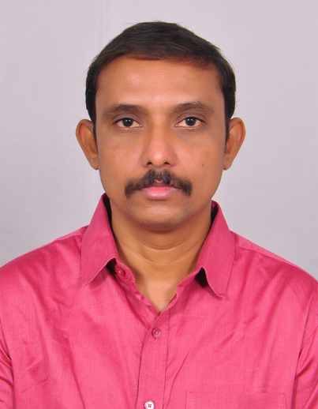
Dr. N. SRIDHAR
Assistant Professor (PT),
Dept. of Geography
University College of Science,
Osmania University, Hyderabad -7
E-mail: nsridhar.hyd@gmail.com Cell : 9492186823

Academic Qualification:

- Post- Doctoral Fellowship (PDF), ICSSR, New Delhi.
- PhD (Geography) from Osmania University, Hyderabad
- M.Sc.(Geo-informatics) from Osmania University, Hyderabad
- P.G .Diploma in Geographical Cartography ,from Osmania University, Hyderabad
- P.G. Diploma in Town & Country Planning , from Osmania University, Hyderabad

Research Experience
- Project Fellow in the Dept. of Geography, OU., from Aug 2008 to March 2012
- Organizing Committee Member of 3 International conferences and 3 National conferences conducted by Department of Geography, Osmania University
Books Authored

- Author of B.A. Geography text books published by Ambedkar Open University, Hyderabad.

