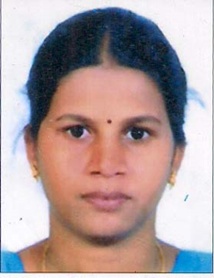

**Dr. D.INDIRA**

Assistant professor (PT)

Department of Geography

University College of science

Osmania University

Phone: 8499849591

indiradonakanti@yahoo.in

**Dr. D.Indira** is currently working as Assistant professor (PT) in the Department of Geography, Osmania University, and Hyderabad, India. She obtained her Bachelor degree in Reddy Womens College, Master and Ph.D. degrees in Department of Geography, Osmania University and PDF from ICSSR New Delhi. She worked as a GIS Engineer in Speck Systems Private Limited.

**Educational Qualifications:**

1. PDF from ICSSR, New Delhi in 2022,

2. Ph.D. awarded from Geography in 2018, Osmania University.

3. P.G.D in Town and Country Planning in 2014.

4. Post-Graduation in Geoinformatics, Osmania University.

5. Degree from R.B.V.R.Reddy Womens College, Osmania University.

6. TS-SET qualified in 2017 from Geography, Osmania University.

**Publications:**

There are more than 5 paper are published in national and International journals and also there are three chapters written in B.A Geography.

**Research experience:**

Organizing member in more than 2 National and International conferences.

**Seminars attended:**

There are more than 2paper presented and attended in national conferences.