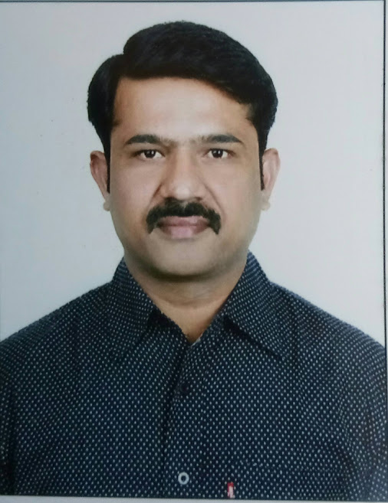
Bio-Data

Prof. Ashok Kumar Lonavath, M.Sc., Ph.D
Professor of Geography,
University College of Science,
Osmania University, Hyderabad, Telangana State

22 years of teaching experience at Department of Geography, Osmania University.

Research Experience:

01 UGC Minor Research Project
26 Papers Published in International & National Journals
23 Papers Presented at International Conferences (India & Abroad)
14 Papers presented at National Conferences (India)
Attended 13 International & 11 National Conferences (India & Abroad)

07 book chapters published in reference books published by International publishers
30 book chapters published in Geography text books published by Telugu Academy,
Government of Telangana
Co-Editor of 05 Reference books published by international publisher
Author of 04 B.A. Geography text books (study material) published by Osmania University.
Co-authored 08 B.A. Geography & PGDTCP text books (study material) published by
Osmania University
98 Book Chapters contributed for B.A Geography & P.G. Diploma in Town & Country planning text books (study material) published by Osmania University.

Administrative Experience:
2 years as Chairman, Board of Studies in Geography, Osmania University
3 years as Head, Department of Geography, University College for women, O.U
2 years as Head, Department of Geography, Post Graduate College of Science, O.U.

2 years as Programme Officer of NSS Unit, Post Graduate College of Science, OU.

Member of Syllabus committee (Geography) NCERT, New Delhi

Member of Syllabus committee (Geography) Board of Intermediate, Government of Telangana

Life member of NAGI - National Association of Geographers India

INCA - Indian National Cartographic Association

DGSI - Deccan Geographical Society of India

UGIT - Union of Geographic Information Technologists

Convenor of 01 National conference & organizing secretary of 3 International conferences and 4 National conferences conducted by Department of Geography, Osmania University

Award: “Best Young Leadership Award” given by Asian Urbanization Research Association (AURA), Shippensburg University of Pennsylvania, USA.

No of Research Scholars working for Ph.D - 08
Countries Visited: China, United Kingdom’s and Thailand, Singapore, Malaysia.

Contact Details:

Prof. Ashok Kumar Lonavath
Contact No: 9247358736
ashokouprof@gmail.com

