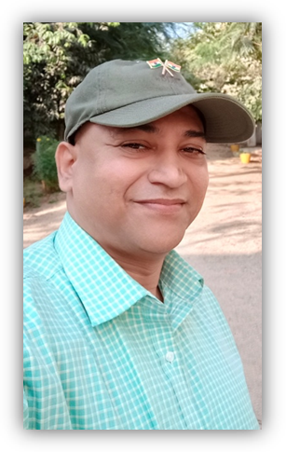
Dr Mohd Akhter Ali is currently working as Assistant professor in the Department of Geography, Osmania University, Hyderabad, India. He obtained his Bachelor, Master and Ph.D.degrees from Osmania University. He specializes in Environmental Geography, Urban and Regional Geography, Cartography, Rural Development, GIS and Remote Sensing. He is editor of many reputed journals in India.
He has about eighteen years of teaching experience to under graduate and Post graduate students.
He is the life members of many academic organizations like NAGI, INCA, ISC, IGU, DGSI, etc.
Dr Mohd Akhter Ali has a credit of getting three books and more than eighty research journals of National and international repute. Presently Six research scholars are perusing research under his supervision.

