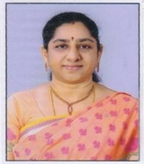

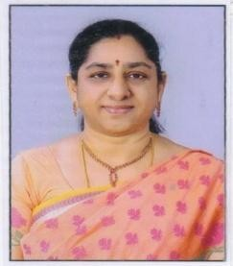**Dr. B. Sireesha M.Sc., Ph.D** *Professor of Inorganic Chemistry , University College of Science, Osmania University.*

*E-mail:* [*berleysiree@gmail.com*](mailto:berleysiree@gmail.com)[*drsireeb@yahoo.co.in*](mailto:drsireeb@yahoo.co.in)  *Ph. No. 91-9391021853*

Dr. B. Sireesha, Professor, Department of Chemistry, Osmania University has been working since 2007 and at UCS, OU from 2019 onwards. She has completed her M.Sc. in Chemistry with Inorganic Chemistry specialization in 1992 and was awarded Ph.D. in Chemistry in 1997 from Osmania University. She has 30 years of teaching experience at

U.G and P.G level and has 28 years of Research Experience, published over 50 Research Papers in reputed International and National Journals with good impact factor. She has also presented 46 research papers in National and International conferences.

Dr. Sireesha’s field of research is Bio-Coordination Chemistry, Computational Chemistry, Crystallography, DNA Binding and Cleavage Studies. 7 Research scholars were awarded PhD Degree under her Supervision, two of her research scholars are writing their thesis. Under her supervision about 27 P.G. students from constituent and affiliated colleges have completed their project dissertation work. She has completed Two UGC Minor research Project 2009-2011 and 2017-2020, funded by UGC-SERO, Hyderabad.

She has delivered guest/invited lectures in various colleges/conferences and refresher courses. She is a Co-Author for TS Government, Telugu Academy English and Telugu media Text books for B.Sc., Chemistry Semesters I, II, III IV and V, for the CBCS Syllabi.

She was a member of several committees at University College of Science, Saidabad and at Nizam College, Osmania University. She worked as In charge-Head, Department of Chemistry, Nizam College, 2017-2019 and worked as Academic Coordinator for 4 years 2014 to 2018, and was instrumental in procuring DST-FIST Level-0 and CPE Phase III funding, and also was coordinator for Implementation of CBCS at UG level and MSc Five year integrated Course in Chemistry at Nizam College, OU.

At present she is the Director, IQAC, Osmania University.

She is a Life member of Indian Chemical society, Kolkata, Indian Association of Chemistry Teachers (IACT) Mumbai, International Society of Teachers and Researchers in Chemistry Bhubaneswar and Indian Society of Analytical Scientists (ISAS) Mumbai.