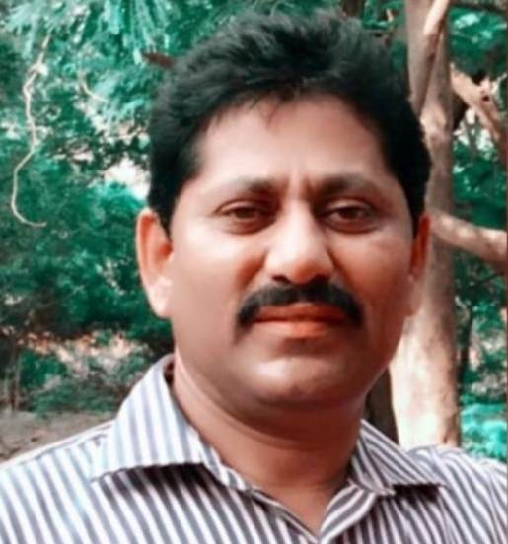**Brief Profile**

**Dr. J. RAMCHANDER** **M.Sc. Ph.D.**

|  |
| --- |
| Professor  Department of Chemistry  University College of Science  Osmania University  Hyderabad-500007,  Telangana State, India.  Mobile No: +91-9908586350  E-mail:  **ramorgchemou@gmail.com** |

Dr. J. Ramchander is working as Professor, Department of Chemistry, University College of Science, Osmania University since march 1998. He received his M.Sc. from Osmania University and awarded Ph.D Degree in Organic Chemistry Osmania University. Then joined as Assistant Professor in P.G. College, Bhiknoor, Osmania University in March 1998. He served as Incharge Principle for 4 years in P.G. College, Bhiknoor, served as warden for 6 year and also served as NSS Program Officer for 3 years then transferred to Nizam College, Osmania University, Hyderabad in June 2009 and as served as In-charge Head Department of Chemistry Nizam College. He has conducted one day National Seminar entitled **“Recent Application in Medicinal and Material Devices” (NSRAMMD-2016**) on 2nd July 2016 as a Convener in Department of Chemistry, Nizam College. After that, he was transferred to University College of Science OU in 2017. He has more than 25 years of teaching and research experience, He has published 21 papers in national and international journals (Citations: 96, h-index: 6, I10 index: 5). He has attended and presented Posters at various National and International Seminars/Conferences/Workshops more than 15. He is presently guiding 08 scholars for their doctoral degree among the 8 scholars one scholar awarded Ph.D degree and one scholar submitted his thesis to the Osmania University, Under his supervision 02 P.G. students have completed their dissertation work. He is life member of Indian Science Congress and Indian Council of a Chemist. He is a member of several committees in Nizam College and University College of Science, Osmania University and Chairman, BOS, M.Sc. Forensic Science OU for Two year and present he is Chairman, BOS, M.Sc Chemistry and Affiliated Engineering Colleges, Dept of Chemistry, OU. Member of Departmental Research Committee, and member of Departmental Committee, Member BOS in Chemistry, Osmania University (UG) and Governing body member and subject expert in many affiliated college and Co-opted member and subject expert in Chaitanya(Deemed to be University) Hanamkonda, Warangal.

**Research Interests:** Organic synthesis involving C-C bond formation and thiazole ring formation and investigation of their photophysical properties and biological evaluation of Heterocyclic Compounds.