Brief Profile  Dr. P. MURALIDHAR REDDY  Assistant Professor, Department of Chemistry,  Osmania University, Mobile No: 9848792423  Email: pmdreddy@osmania.ac.in, pmdreddy@gmail.com  Home page  https://sites.google.com/view/drpmdreddy/home  Citations Indices  https://scholar.google.com/citations?hl=en&user=uSMnZokAAAAJ&view_op=list_works | 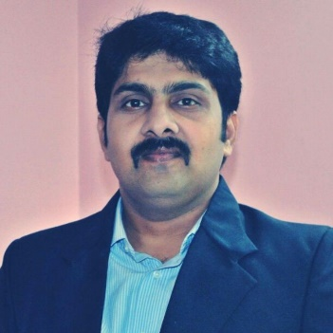
Dr. P. Muralidhar Reddy working as Assistant Professor, Department of Chemistry, Osmania University since 2013. He has received B.Sc., M.Sc., and Ph.D. in chemistry from Kakatiya University, Telangana State, India.
Dr. P.M. Reddy worked as a visiting faculty member at Tzu Chi University, Hualien in 2014 and 2024. He worked as Postdoctoral Fellow (PDF) at National Dong Hwa University (NDHU), Taiwan from August 2007 to September 2013. He also has Industrial Experience in Analytical Research and Development (AR&D), Hetro Drugs Limited (R&D), Hyderabad, India.
He has authored 7 book chapters and 120 Research articles, which have been published in reputed International and National Journals with h-index of 27, i10index of 46 and 5 patents to his credit. He has also presented research papers in 90 National and 60 International conferences. He has delivered guest/invited lectures in various colleges/conferences. He is a Life member of Indian Council of Chemists (ICC), Indian Science Congress Association (ISCA), Member of Taiwan society for mass spectrometry (TSMS) and Association of Pharmacy Professionals (APP). He is a reviewer for over 20 National and International professional journals.
He has 18 years of teaching and 22 years of research experience. His research focuses on Coordination Chemistry, Bioinorganic Chemistry, Organometallic Chemistry, Biological Activity, Catalytic Applications on Drugs; Synthesis & Development of functionalized magnetic Iron oxide (Fe₃O₄), Titanium dioxide (TiO₂), and Silver (Ag) Nanoparticles towards Biological Applications and Developing Mass Spectrometric Methods for Analysis of various Microorganisms.
Under his supervision, 23 P.G., 11 M. Pharm and 8 Ph.D. students have completed their dissertation work and 4 scholars are currently working for their Ph.D. degree. His research activities Total 6 Major Projects (2-National and 4-International Projects) and 4 Minor Projects are supported by various funding agencies like NSC-Taiwan, Tzu Chi University, UGC, TSCOST, DST and CSIR, New Delhi, India. He has served as member in several committees of Nizam College, Osmania University from October 2013 to January 2020. He Worked as Placement Officer, Nizam College, Osmania University from August 2014-July 2019 and Controller of Examination (COE), Nizam College, Osmania University from October 2018 to February 2020. Currently he is a Joint Secretary, Osmania University Chemistry Foundation (OUCF), Coordinator for Human Capital Development Center (HCDC), Osmania University and Placement Officer, UCS, Osmania University.
Dr. P.M. Reddy is recipient of Best Teacher Award-2015 (Nation Builder Award-2015) for the cause of educating the future generation of our country, 5th September 2015, Also, recipient of Ideal Teaching Awards -2018 Selected in the Category of Professor of the Year (Chemistry) and Seva Ratna Award 2020, Mother Teresa Gold Medal Award- 2021. Received Best Paper Presentation Award (Ranked First) in ICNN-2011, RAC-2015, NPC-2020 and ETCMSR-2022. He has received two gold medals in B.Sc. and M.Sc. and also received the most popular student award in 1999.

