Brief Profile  Dr. Laxma Reddy Kotha  M.Sc., Ph. D.  Assistant Professor  Department of Chemistry,  Osmania University,  Email: klreddy200542@gmail.com | 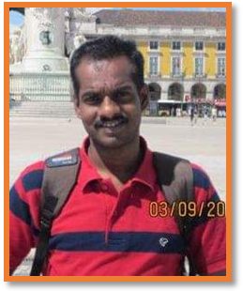
Dr. Laxma Reddy Kotha working as Assistant Professor, Department of Chemistry, Osmania University since 2013. He has received B.Sc., M.Sc., and Ph.D. in chemistry from Osmania University, Telangana State, India. Dr. K.L. Reddy worked as Postdoctoral Fellow (PDF) Fundação para a Ciência e a Tecnologia Research Fellow (FCT), at ITQB, Oeiras, Portugal from July 2011 to August 2012.
He has 34 Research articles, which have been published in reputed International and National Journals. He has also presented research papers in 20 National and 10 International conferences. He has delivered guest/invited lectures in various colleges/conferences. He is a Life member of Indian Science Congress Association (ISCA), India.
He has 12 years of teaching and 17 years of research experience. His research focuses on Coordination Chemistry, Bioinorganic Chemistry, Organometallic Chemistry, DNA Binding Studies and Biological Activities of TMCS.
Under his supervision 4 scholars are currently working for their Ph.D. degree. His research activities supported by funding agencies like UGC, and APCOST, India. He has served as member in several committees of UCT, Osmania University from November 2016 to January 2022. He Worked as Pincipal, OUPG College, Mirzapur, Osmania University from November 2013 to November 2016. Currently he is working as Additional Chief Warden, Hostels and Messes, Osmania University
Dr. K.L. Reddy is recipient of Young Scientist Award (Govt. of AP, 2009) and also Received Best Paper Presentation Award (Ranked First) in ETCMSR-2022.

