B.Sc(Computer Science): III Year
90 hrs
(3 hrs/ week)

THEORY PAPER – III

Database Management Systems

Unit-1 : Database Systems Introduction and Fundamentals. 18 hrs

Database Systems: Introducing the database and DBMS, Why the database is important, Historical Roots: Files and File Systems, Problems with File System Data Management, Database Systems.

Data Models: The importance of Data models, Data Model Basic Building Blocks, Business Rules, The evaluation of Data Models, Degree of Data Abstraction.

The Relational Database Model: A logical view of Data, Keys, Integrity Rules, Relational Set Operators, The Data Dictionary and the system catalog, Relationships with in the Relational Database, Data Redundancy revisited, Indexes, Codd’s relational database rules.

(Chapters:1: 1.2 to 1.6,2,3)

Unit-2 : Data Modeling and Normalization 18 hrs

Entity Relationship Model: The ER Model, Developing ER Diagram, Database Design Challenges: Conflicting Goals.

Advanced Data Modeling: The Extended Entity Relationship Model, Entity clustering, Entity integrity: Selecting Primary keys, Design Cases: Learning Flexible Database Design.

Normalization of database tables: Database Tables and Normalization, The need for Normalization, The Normalization Process, Improving the design, Surrogate Key Considerations, High level Normal Forms, Normalization and database design, denormalization.

(Chapters: 4,6,5)

Unit-3 : Interaction with Databases and Construction of Information System 18 hrs

Introduction to SQL: Data Definition Commands, Data Manipulation Commands, Select queries, Advanced Data Definition Commands, Advanced Select queries, Virtual Tables, Joining Database Tables.

Advanced SQL: Relational Set Operators, SQL Join Operators, Subqueries and correlated queries, SQL Functions, Oracle Sequences, Updatable Views, and Procedural SQL.

Database Design: The Information System, The Systems Development Life Cycle, The Database Life Cycle, Database Design Strategies, Centralized Vs Decentralized design.

(Chapters: 7,8(8.1 to 8.7),9)

Unit-4 : Transaction Management in DBMS Environment. 18 hrs

Transaction Management and Concurrency Control: What is transaction, Concurrency control, Concurrency control with locking Methods, Concurrency control with time stamping methods, concurrency control with optimistic methods, database recovery management.

Distributed Database Management Systems: The evolution of Distributed Database Management Systems, DDBMS advantages and Disadvantages, Distribution Processing and Distribution Databases, Characteristics of Distributed database management systems, DDBMS Components, Levels of Data and Process distribution, Distributed database Transparency Features, Distributed Transparency, Transaction Transparency, Performance Transparency and Query Optimization, Distributed Database Design, Client Server VS DDBMS.

(Chapters: 10, 12)

Unit-5 : Data Warehouse Concepts and Database Administration. 18 hrs

The Data Warehouse: The need for data analysis, Decision support systems, The data warehouse, Online analytical processing, Star schemas, Data mining, SQL extension for OLAP.

Database Administration: Data as a Corporate asset, The need for and role of databases in an organization, The evolution of the database administration function, The database environment’s Human Component, Database administration Tools, The DBA at work: Using Oracle for Database Administration.

(Chapter: 13:13.1 to 3.5,13.7,13.8,15:15.1,15.2,15.4,15.5,15.6,15.8)

Prescribed Text Book:

- Peter Rob, Carlos Coronel, Database Systems Design, Implementation and Management, Seventh Edition, Thomson (2007)
Reference Books:

- Elimasri / Navathe, Fundamentals of Database Systems, Fifth Edition, Pearson Addison Wesley (2007).

- Raman A Mata – Toledo/Panline K Cushman, Database Management Systems, Schaum’s Outlibe series, Tata McGraw Hill (2007).

- C.J.Date, A.Kannan, S.Swamynathan, An Introduction to Database Systems, Eight Edition, Pearson Education (2006).

- Michel Kifer, Arthur Bernstein, Philip M. Lewis, Prabin K. Pani Graphi, Database Systems: An application oriented Approach, second edition, pearson education (2008).
- Atul Kahate, Introduction to Database Management Systems, Pearson Education (2006).
B.Sc(Computer Science): III Year
90 hrs
(3 hrs/ week)
PRACTICAL PAPER – III

DBMS Lab

Lab Cycle
Order Tracking Database

The Order Tracking Database consists of the following defined six relation schemas.

EMPLOYEES(ENO,ENAME,ZIP,HDATE)
PARTS(PNO,PNAME,QOH,PRICE,LEVEL) (HINT: QOH: QUALITY ON HAND)
CUSTOMERS(CNO,CNAME,STREET,ZIP,PHONE)
ORDERS(ONO,CNO,ENO,RECEIVED DATE,SHIPPED DATE)
ODETAILS(ONO,PNO,QTY)
ZIPCODES(ZIP,CITY)

Solve the following queries

1. GET ALL PAIRS OF CUSTOMER NUMBERS FOR CUSTOMERS BASED ON SAME ZIP CODE.

2. GET PART NUMBERS FOR PARTS THAT HAVE BEEN ORDERED BY AT LEAST TWO DIFFERENT
CUSTOMERS.

3. FOR EACH ODETAIL ROW, GET ONO, PNO, PNAME, QTY AND PRICE VALUES ALONG WITH
THE TOTAL PRICE FOR THE ITEM. (TOTAL PRICE=PRICE*QTY)

4. GET CUSTOMER NAME AND EMPLOYEE PAIRS SUCH THAT THE CUSTOMER WITH NAME
HAS PLACED AN ORDER THROUGH THE EMPLOYEE.

5. GET CUSTOMER NAMES LIVING IN FORT DODGE OR LIBERAL.

6. GET CNAME VALUES OF CUSTOMERS WHO HAVE ORDERED A PRODUCT WITH
PNO 10506.

7. GET PNAME VALUES OF PARTS WITH THE LOWEST PRICE.

8. GET CNAME VALUES OF CUSTOMERS WHO HAVE PLACED AT LEAST ONE ORDER
THROUGH THE EMPLOYEE WITH NUMBER 1000.

9. GET THE CITIES IN WHICH CUSTOMERS OR EMPLOYEES ARE LOCATED.

10. GET THE TOTAL SALES IN DOLLARS ON ALL ORDERS.

11. GET PART NAME VALUES THAT COST MORE THAN THE AVERAGE COST OF ALL
PARTS.

12. GET PART NAMES OF PARTS ORDERED BY AT LEAST TWO DIFFERENT
CUSTOMERS.

13. GET FOR EACH PART GET PNO,PNAME AND TOTAL SALES

14. FOR EACH PART, GET PNO,PNAME, TOTAL SALES, WHOSE TOTAL SALES EXCEEDS
1000

15. GET PNO, PART NAMES OF PARTS ORDERED BY AT LEAST TWO DIFFERENT
CUSTOMERS.

16. GET CNAME VALUES OF CUSTOMERS WHO HAVE ORDERED PARTS FROM ANY ONE
EMPLOYEE BASED IN WICHITA OR LIBERAL.

SHIPMENT DATABASE

AN ENTERPRISE WISHES TO MAINTAIN THE DETAILS ABOUT HIS SUPPLIERS AND OTHER CORRESPONDING DETAILS. FOR THAT IT USES THE FOLLOWING TABLES

TABLE S(SID,SNAME,ADDRESS)

PRIMARY KEY : SID

TABLE P(PID,PNAME,COLOR)

PRIMARY KEY : PID

TABLE CAT(SID,PID,COST)

PRIMARY KEY : SID+PID

REFERENCE KEY : SID REFERENCES S.SID
PID REFERENCES P.PID

Solve the following queries

1. FIND THE PNAMES OF PARTS FOR WHICH THERE IS SOME SUPPLIER

2. FIND THE SNAMES OF SUPPLIERS WHO SUPPLY EVERY PART.

3. FIND THE SNAMES OF SUPPLIERS WHO SUPPY EVERY RED PART.

4. FIND THE PNAMES OF PARTS SUPLLIED BY LONDON SUPPLIER AND BY NO
ONE ELSE

5. FIND THE SIDS OF SUPPLIERS WHO CHARGE MORE FOR SOME PART OTHER
THAN THE AVERAGE COST OF THAT PART

6. USING GROUP BY WITH HAVING CLAUSE GET THE PART NUMBERS FOR ALL
THE PARTS SUPPLIED BY MORE THAN ONE SUPPLIER.

7. GET THE NAMES OF THE SUPPLIERS, WHO DO NOT SUPPLY PART P2.

8. FIND THE SIDS OF SUPPLIERS WHO SUPPLY A RED AND A GREEN PART

9. FIND THE SIDS OF SUPPLIERS WHO SUPPLY A RED OR A GREEN PART

10.FIND THE TOTAL AMOUNT HAS TO PAY FOR THAT SUPPLIER BY PART
LOCATED FROM LONDON

Employee Database

An enterprise wishes to maintain a database to automate its operations. Enterprise divided into to certain departments and each department consists of employees. The following two tables describes the automation schemas

DEPT (DEPTNO, DNAME, LOC)
EMP (EMPNO,ENAME,JOB,MGR,HIREDATE,SAL,COMM,DEPTNO)

1. CREATE A VIEW, WHICH CONTAIN EMPLOYEE NAMES AND THEIR MANAGER
NAMES WORKING IN SALES DEPARTMENT.

2. DETERMINE THE NAMES OF EMPLOYEE, WHO EARN MORE THAN THEIR
MANAGERS.

3. DETERMINE THE NAMES OF EMPLOYEES, WHO TAKE HIGHEST SALARY IN
THEIR DEPARTMENTS.

4. DETERMINE THE EMPLOYEES, WHO LOCATED AT THE SAME PLACE.

5. DETERMINE THE EMPLOYEES, WHOSE TOTAL SALARY IS LIKE THE MINIMUM
SALARY OF ANY DEPARTMENT.

6. UPDATE THE EMPLOYEE SALARY BY 25%, WHOSE EXPERIENCE IS GREATER THAN
10 YEARS.

7. DELETE THE EMPLOYEES, WHO COMPLETED 32 YEARS OF SERVICE.

8. DETERMINE THE MINIMUM SALARY OF AN EMPLOYEE AND HIS DETAILS, WHO
JOIN ON THE SAME DATE.

9. DETERMINE THE COUNT OF EMPLOYEES, WHO ARE TAKING COMMISSION AND NOT
TAKING COMMISSION.

10. DETERMINE THE DEPARTMENT DOES NOT CONTAIN ANY EMPLOYEES.

11. FIND OUT THE DETAILS OF TOP 5 EARNER OF COMPANY.

12. DISPLAY THOSE MANAGERS NAME WHOSE SALARY IS MORE THAN AVERAGE SALARY OF HIS EMPLOYEES.

13. DISPLAY THOSE EMPLOYEES WHO JOINED THE COMPANY BEFORE 15TH OF THE
MONTH?

14. DISPLAY THE MANAGER WHO IS HAVING MAXIMUM NUMBER OF EMPLOYEES
WORKING UNDER HIM?

15. PRINT A LIST OF EMPLOYEES DISPLAYING ‘LESS SALARY’ IF LESS THAN 1500 IF EXACTLY 1500 DISPLAY AS ‘EXACT SALARY’ AND IF GREATER THAN 1500 DISPLAY ‘MORE SALARY’?

16. DISPLAY THOSE EMPLOYEES WHOSE FIRST 2 CHARACTERS FROM HIRE DATE-LAST 2 CHARACTERS OF SALARY?

17. DISPLAY THOSE EMPLOYEES WHOSE 10% OF SALARY IS EQUAL TO THE YEAR OF JOINING?

18. IN WHICH YEAR DID MOST PEOPLE JOIN THE COMPANY? DISPLAY THE YEAR AND
NUMBER OF EMPLOYEES.

19. DISPLAY THE HALF OF THE ENAMES IN UPPER CASE AND REMAINING LOWER
CASE

20. DISPLAY ENAME, DNAME EVEN IF THERE NO EMPLOYEES WORKING IN A PARTICULAR DEPARTMENT(USE OUTER JOIN).

University Database

University wishes to computerise their operations by using the following relations.

Student (snum:Integer, sname: string, major: string, level: string,
age: integer)
Class (name: String, Hour:Integer, room: string, fid: integer)
Enrolled (sum: integer, cname: string)
Faculty (fid: Integer, fname: String, deptid: Integer)
Depart (deptid: Integer, dname: String, loc: integer)

By using above schema definitions, resolve the following queries

- FIND THE NAMES OF ALL JUNIORS (LEVEL=JR) WHO ARE ENROLLED IN A CLASS TAUGHT BY SMITH.
- FIND THE AGE OF THE OLDEST STUDENT WHO IS EITHER A HISTORY MAJOR OR IS ENROLLED IN THE COURSE OF SMITH.
- FIND THE NAMES OF ALL CLASSES THAT EITHER MEET R128 OR HAVE FIVE OR MORE STUDENTS ENROLLED.
- FIND THE NAMES OF ALL STUDENTS WHO ARE ENROLLED IN TWO CLASSES THAT MEET AT THE SAME HOUR.
- FIND THE NAMES OF FACULTY MEMBERS WHO TEACH IN EVERY ROOM IN, WHICH SOME CLASS IS TAUGHT.
- FIND THE NAMES OF FACULTY MEMBERS FOR WHOM THE COMBINED ENROLLMENT OF THE COURSES THAT THEY TEACH IS LESS THAN FIVE.
- PRINT THE LEVEL AND AVERAGE AGE OF STUDENTS FOR THAT LEVEL, FOR EACH LEVEL.
- PRINT THE LEVEL AND AVERAGE AGE OF THE STUDENT FOR THAT LEVEL, FOR ALL LEVELS EXCEPT JR.
- FIND THE NAMES OF STUDENTS WHO ARE ENROLLED IN THE MAXIMUM NUMBER OF CLASSES.
- FIND THE NAMES OF THE STUDENTS WHO ARE NOT ENROLLED IN ANY CLASS.

Airline Database

An Airline System would like to keep track their information by using the following relations.

Flights (flno: integer, from: string, to: string, distance: integer,
Price: integer)
Aircraft (aid: integer, aname: string, cruising_range: integer)
Certified (eid: integer, aid: integer)
Employees (eid: integer, ename: string, salary: real)

Note that the employees relation describes pilots and other kinds of employees as well; every pilot is certified for aircraft and only pilots are certified to fly. Resolve the following queries:

- FOR EACH PILOT WHO IS CERTIFIED FOR MORE THAN THREE AIRCRAFT, FIND THE EID’S AND THE MAXIMUM CRUISING RANGE OF THE AIRCRAFT THAT HE (OR SHE) CERTIFIED FOR.
- FIND THE NAMES OF PILOTS WHOSE SALARY IS LESS THAN THE PRICE OF THE CHEAPEST ROUTE FROM LOS ANGELES TO HONOLULU.
- FIND THE NAME OF THE PILOTS CERTIFIED FROM SOME BOEING AIRCRAFT.
- FOR ALL AIRCRAFT WITH CRUISING RANGE OVER 1,000 MILES, FIND THE NAME OF THE AIRCRAFT AND THE AVERAGE SALARY OF ALL PILOTS CERTIFIED FOR THIS AIRCRAFT.
- FIND THE AID’S OF ALL AIRCRAFT THAT CAN BE USED FROM LOS ANGELS TO CHICAGO.
- PRINT THE ENAMES OF PILOTS WHO CAN OPERATE PLANES WITH CRUISING RANGE GREATER THAN 3,000 MILES, BUT ARE NOT CERTIFIED BY BOEING AIRCRAFT.
- FIND THE TOTAL AMOUNT PAID TO EMPLOYEES AS SALARIES.
- FIND THE EID’S OF EMPLOYEES WHO ARE CERTIFIED FOR EXACTLY THREE AIRCRAFTS.
- FIND THE EID’S OF EMPLOYEE WHO MAKE SECOND HIGHEST SALARY.
- FIND THE AID’S OF ALL THAN CAN BE USED ON NON-STOP FLIGHTS FROM BONN TO CHENNAI.

PL/SQL PROGRAMS

1. WRITE A PL/SQL PROGRAM TO CHECK THE GIVEN NUMBER IS STRONG OR NOT.
2. WRITE A PL/SQL PROGRAM TO CHECK THE GIVEN STRING IS PALINDROME OR NOT.
3. WRITE A PL/SQL PROGRAM TO SWAP TWO NUMBERS WITHOUT USING THIRD VARIABLE.

4. WRITE A PL/SQL PROGRAM TO GENERATE MULTIPLICATION TABLES FOR 2,4,6

5. WRITE A PL/SQL PROGRAM TO DISPLAY SUM OF EVEN NUMBERS AND SUM OF ODD

NUMBERS IN THE GIVEN RANGE.

6. WRITE A PL/SQL PROGRAM TO CHECK THE GIVEN NUMBER IS POLLINNDROME OR NOT.
7. THE HRD MANAGER HAS DECIDED TO RAISE THE EMPLOYEE SALARY BY 15%. WRITE A
PL/SQL BLOCK TO ACCEPT THE EMPLOYEE NUMBER AND UPDATE THE SALARY OF THAT
EMPLOYEE. DISPLAY APPROPRIATE MESSAGE BASED ON THE EXISTENCE OF THE
RECORD IN EMP TABLE.
8. WRITE A PL/SQL PROGRAM TO DISPLAY TOP 10 ROWS IN EMP TABLE BASED ON
THEIR JOB AND SALARY.
9. WRITE A PL/SQL PROGRAM TO RAISE THE EMPLOYEE SALARY BY 10%, FOR
DEPARTMENT NUMBER 30 PEOPLE AND ALSO MAINTAIN THE RAISED DETAILS IN THE
RAISE TABLE.
10. WRITE A PROCEDURE TO UPDATE THE SALARY OF EMPLOYEE, WHO ARE NOT GETTING
COMMISSION BY 10%
11.WRITE A PL/SQL PROCEDURE TO PREPARE AN ELECTRICITY BILL BY USING
FOLLOWING TABLE

TABLE USED: ELECT

NAME NULL? TYPE

MNO NOT NULL NUMBER(3)
CNAME VARCHAR2(20)
CUR_READ NUMBER(5)
PREV_READ NUMBER(5)
NO_UNITS NUMBER(5)
AMOUNT NUMBER(8,2)
SER_TAX NUMBER(8,2)
NET_AMT NUMBER(9,2)

12. WRITE A PL/SQL PROCEDURE TO PREPARE AN TELEPHONE BILL BY USING
FOLLOWING TABLE. AND PRINT THE MOTHLY BILLS FOR EACH CUSTOMER
TABLE USED : PHONE.
NAME NULL? TYPE
----------------------------- -------- ----
TEL_NO NOT NULL NUMBER(6)
CNAME VARCHAR2(20)
CITY VARCHAR2(10)
PR_READ NUMBER(5)
CUR_READ NUMBER(5)
NET_UNITS NUMBER(5)
TOT_AMT NUMBER(8,2)

13. WRITE A PL/SQL PROGRAM TO RAISE THE EMPLOYEE SALARY BY 10%,
WHO ARE COMPLETED THERE 25 YEARS OF SERVICE.

14. WRITE A PL/SQL PROCEDURE TO EVALUATE THE GRADE OF A STUDENT WITH
FOLLOWING CONDITIONS:

- FOR PASS: ALL MARKS > 40
- FOR I CLASS: TOTAL%>59
- FOR II CLASS: TOTAL% BETWEEN >40 AND <60
- FOR III CLASS: TOTAL% =40
AND ALSO MAINTAIN THE DETAILS IN ABSTRACT TABLE.

TABLES USED

TABLE STD

SQL> DESC STD
NAME NULL? TYPE
------------------------------- -------- ----
NO NOT NULL NUMBER
NAME VARCHAR2(10)
INTNO NUMBER
CLASS NOT NULL VARCHAR2(10)
M1 NUMBER
M2 NUMBER
M3 NUMBER
M4 NUMBER
M5 NUMBER

TABLE ABSTRACT

SQL> DESC ABSTRACT
NAME NULL? TYPE
------------------------------- -------- ----
STDNO NUMBER
STDNAME VARCHAR2(10)
CLASS VARCHAR2(10)
INTNO NUMBER
TOT NUMBER
GRADE VARCHAR2(10)
PERCENT NUMBER
DAT_ENTER DATE

15. WRITE A PROCEDURE TO UPDATE THE SALARY OF EMPLOYEE, WHO BELONGS TO
CERTAIN DEPARTMENT WITH A CERTAIN PERCENTAGE OF RAISE.

B.Sc.(Computer Science): III Year
90 hrs
(3 hrs/ week)

THEORY PAPER – IV
(Elective – 1)
Web Technologies

UNIT-1 : HTML Basics 18 hrs

Introduction: HTML, XML, and the World Wide Web.

HTML: Basic HTML, The Document body, Text, Hyperlinks, Adding more formatting, Lists, Tables, Using colors and images, Images.

More HTML: Multimedia objects, Frames, Forms-towards interactivity, The HTML document Head in detail, XHTML- An evolutionary markup.

UNIT-2 : Introduction to the Style Sheets and Java Scripts. 18 hrs

Cascading Style Sheets: Introduction, Using styles: Simple examples, Defining your own styles, Properties and values in styles, Style sheets- A worked example, Formatting blocks of information, Layers.

An introduction to Java Script: What is dynamic html, Java Script, Javascript—The basics, Variables, String manipulation, Mathematical functions, Statements, Operators, Arrays, Functions.

UNIT-3 : Objects in Java Script and DHTML. 18 hrs

Objects in Java Script: Data and objects in java script, Regular expressions, Exception Handling, Built in objects, Events.

Dynamic HTML with Java Script: Data validation, Opening a new window, Messages and Confirmations, The status bar, Writing to a different frame, Rollover buttons, Moving images, Multiple pages in a single download, A text-only menu system, Floating logos.

UNIT-4 : ASP and XML. 18 hrs

Active Server Pages and Java: Active Server Pages, Java.

XML: Defining Data for Web applications: Basic XML, Document type definition, XML schema, Document Object Model, Presenting XML

Good Design: Structure, Tables versus Frames, Accessibility, Internationalization, Exercises.

UNIT-5 : Web Based Softwares and Protocols. 18 hrs

Useful Software: Web browsers, Perl, Web servers, mod_perl, Databases, Accessing your ISP, Exercises.

Protocols: Protocols, IP and TCP, Hyper Text Transfer Protocol, Common Gateway Interface, The Document Object Model, introducing the Document Object Model, Exercises.

Case Study: The plan, The data

Prescribed Book:

- Chris Bates, Web Programming Building Internet Applications, Second Edition, Wiley (2007)

Reference Books:

- Paul S.Wang Sanda S. Katila, An Introduction to Web Design Plus Programming, Thomson(2007).

- Robert W.Sebesta, Programming the World Wide Web, Third Edition, Pearson Education (2007).

- Thomas A.Powell, The Complete Reference HTML & XHTML, Fourth Edition, Tata McGraw Hill (2006).

- Abders Moller and Michael Schwartzbach, An Introduction to XML and Web Technologies, Addison Wesley (2006).

- Joel Sklar, Principles of Web Design, Thomson (2007).

- Raj Kamal, Internet and Web Technologies, Tata McGraw Hill (2007).

- Deitel, et al.,Internet and World Wide Web: How to Program, 3rd Edition, PHI (2008).

- Gopalan & Akilandeswari, Web Technology: A Developer’s Perspective, PHI (2008).

B.Sc(Computer Science): III Year
PRACTICAL PAPER – IV
90 hrs
(3 hrs/ week)
(Elective – 1)
Web Technologies Lab

Lab Cycle

1. Write a HTML program illustrating text formatting.

2. Illustrate font variations in your HTML code.

3. Prepare a sample code to illustrate links between different
sections of the page.

4. Create a simple HTML program to illustrate three types of lists.

5. Embed a real player in your web page.

6. Embed a calendar object in your web page.

7. Create an applet that accepts two numbers and perform all the
arithmetic operations on them.

8. Create nested table to store your curriculum.

9. Create a form that accepts the information from the subscriber of
a mailing system.

10. Design the page as follows:
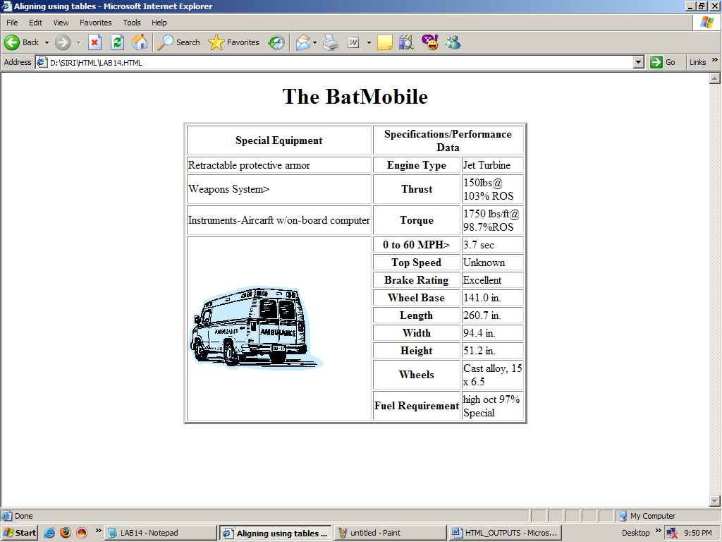

11. Using “table” tag, align the images as follows:
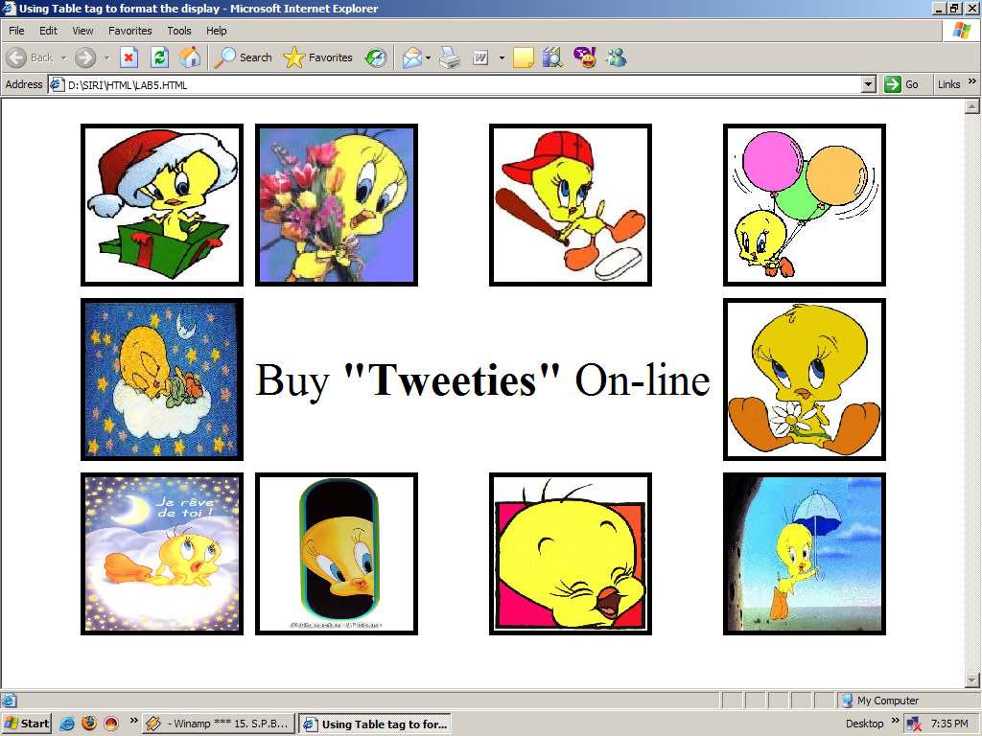

12. Divide the web page as follows:
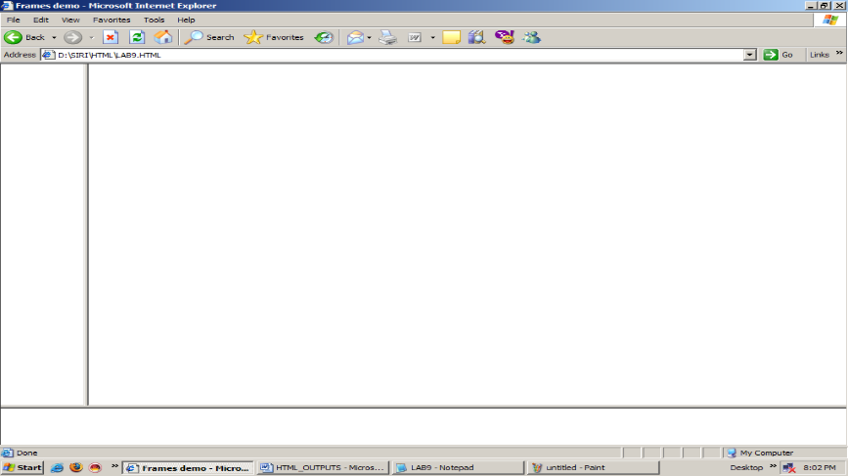

13. Design the page as follows:
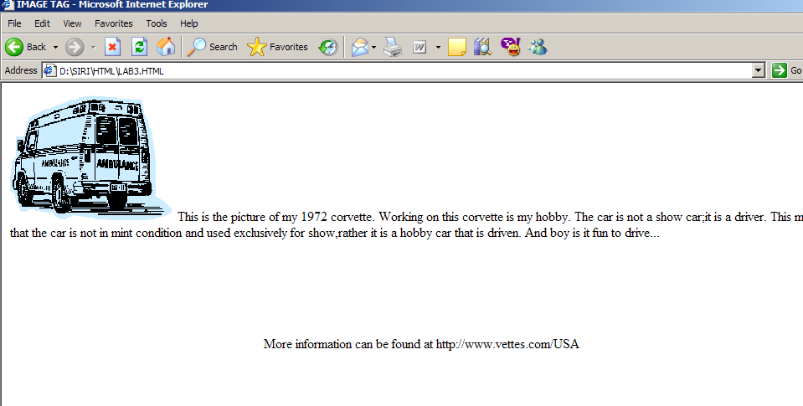

14. Illustrate the horizontal rulers in your page.
15. Create a help file as follows:
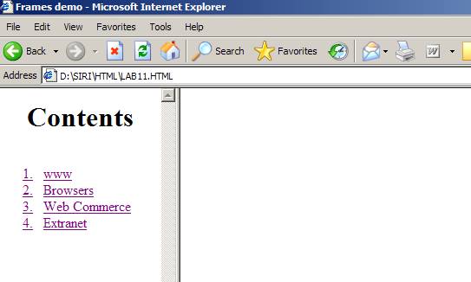
16. Write a Java Script to accept the first, middle and last names
of the user and print the name.

17. Evaluate the following:
  - “10”+”90”
  - (10<8)>10:8
  - J=(i++)+(--i)+(++i)+(i++) where i=2
18. Write a Program in Java Script to add two numbers.
19. Write a script to find the factorial of a given number using
functions.

20. Write a script to print all primes with in the given range.

21. Write a program to sort the array elements using “Bubble Sort”
technique.

22. Write a program in Java Script to implement “Binary Search”
technique.

23. Write a script to print all perfect numbers with in the given
range.

24. Write a script to evaluate the following expression:
1+2/2! +3/3! +……+n/n!
25. Write a program to implement “Stack” operations.
26. Write a script to print Fibonacci series recursive functions.

27. Using a ternary operator, write a script to validate the
withdrawal transaction of a customer. If he with draws more than
his balance, such a transaction should be disallowed.

28. Write a script to wish the user “Good Morning” at different
hoursof the day.
B.Sc(Computer Science): III Year: Lab-4.1 (Continued)

29.Prompt the user for the cost price and selling price of an
article and output the profit or loss percentage.
30.Create a customer profile for data entry of customers in a hotel.
The profile should prompt for the name, address, gender, age,
room type, mode of payment of the customer.
31.Create a student registration system with the following fields:
Name, Regdno, Gender, street, city, state, pincode, stdcode, phone, dbirth, college, experience, course code. Create a main object called “Stu_info” with all the fields and “College” and “Experience” as sub objects with in the main object. Create separate object definition for College and Experience with the following fields:
College: Name, Location, Degree
Experience: Employer, Location, Duties and Period
32.Write a script to read information of ‘n’ students from the user
and store them into the table as follows:
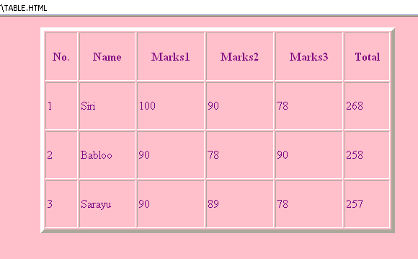
33.Write the script for the various validations given below:
  - Candidate code should be generated
  - Date of Birth should not be null and age should be more than 21.
  - All alphabet fields should be validated.
  - All number fields should accept only numbers.
  - Total experience should be calculated and displayed after accepting input for the “From” and “To” fields in the table.
34. Create a bio-data format with the following fields:
Name, candidate code, Date of birth, Gender, Address1, Address2, Phone, Passport number, Qualification and Percentage.
Also, create the following fields for entering present employment details:
Company name Company Address1, Address2, Address3, Phone, Fax, E-mail, Total Experience and Project details.
Create a table with the columns given below in a 3 row structure:
Employer name, Location, From, To, Field
35. Create a web page for a shopping mall that allows the user to tick off his purchases and obtain a
bill with the total being simultaneously added up. The web page must follow the specifications as
given below:
a.The entire web page must be divided into four portions. The top most portion states the name of the mall, the middle portion of the web page is divided vertically into two, the types of the items available in the mall are displayed on the left side and a detailed description of each item with the prices are available on the right. Finally, the bottom most portion of the web page must display the cash memo with the total along side.
b.Each item in the left hand frame must have a link to the file containing its detailed description, which must be displayed in the right hand frame. Ensure that the user is able to perceive only that portion of the file that is related to the item on which he clicked. Prior to the link being activated, the right hand frame must display a friendly message that gives an idea about its latter contents.
36. Design a simple calculator.
37. Write a DHTML program to give different colors for different heading tags.
38.Using DHTML, invert the behavior of <h1> to <h6> tags.
39.Create an inline style sheet for your web page.
40. Create an external style sheet for creating a font family.
41. Illustrate the creation of embedded style sheet.
42. Illustrate the procedure of creating user-defined classes.
43. Write an ASP script to send the information accepted from the user and send it to a CGI script.
44. Write an ASP script to update the student information with some number ‘n’ in the table.
45. Delete the desired student’s record from the table using the ASP Script.

B.Sc.(Computer Science): III Year
90 hrs
(3 hrs/ week)
THEORY PAPER – IV
(Elective – 2)
GUI Programming

Unit-1 : Familiarization about the Visual Basic IDE Components. 18 hrs

Getting Starting with Visual Basic 6.0: Introduction to Visual Basic, Visual Basic 6.0 Programming Environment, working with Forms, Developing an Application, Variables, Data types and Modules, Procedures and Control Structures, Arrays in Visual Basic

Working with Controls: Introduction, Creating and Using Controls, Working with Control Arrays.

Menus, Mouse Events and Dialog Boxes: Introduction, Mouse Events, Dialog Boxes.

(Chapters:1,2,3)

Unit-2 : Objects, Classes and Add-Ins 18 hrs

Graphics, MDI and Flex Grid: Introduction, Graphics for application, Multiple Document Interface(MDI), Using FlexGrid Control.

Object Linking and Embedding: Introduction, OLE Fundamentals, Using OLE Container Control, Using ILE Automation Objects, OLE Drag and Drop.

Objects and Classes: Introduction to Objects. Working with Objects, Classes and Class Modules.

Working with Add-Ins: Introduction to Add-Ins, Building Add-Ins.

(Chapters: 4, 8, 9, 14)

Unit-3 : File System, ODBC and ActiveX features 18 hrs

File and File system Controls: Introduction, File System Controls, Accessing Files, Interface with Windows.

ODBC and Data Access Objects: Evolution of Computing Architectures, Data Access Options.

ODBC using Data Access Objects and Remote Data Objects: Open Database Connectivity, Remote Data Objects.

Working with ActiveX Data Objects: An overview of ADO and OLEDB, ADO object Model.

(Chapters: 17,5,6,16)

Unit-4 : Data Environment ActiveX EXE and DLL 18 hrs

Data Environment and Data Report: Introduction, Data Environment Designer, Data Report.

All about ActiveX Controls: Introduction, Constituents of ActiveX Control, Exposing AcrivX Control Properties.

ActiveX EXE and ActiveX DLL: Introduction to ActiveX EXE and ActiveX DLL, Creating and ActiveX EXE Component, Creating an ActiveX DLL Component.

(Chapters: 7,10,11)

Unit-5 : Web Browser and DHTML Programming with Visual Basic. 18 hrs

ActiveX Document Fundamentals: What is an ActiveX Document, Active Server Pages.

Built-in ActiveX Controls: Working with Built-in ActiveX Controls, Additional ActiveX Controls.

Introducing Web Browser and DHTML: Introduction, Internet Tools in Visual Basic, Using DHTML in Visual Basic.

(Chapters: 12,13,15)

Prescribed Text Book:

- Content Development Group, Visual Basic 6.0 Programming, Tata McGraw-Hill Publishing Company Limited (2007).

Reference Books :

- Deitel and Deitel, Visual Basic 2005, Third Edition, Pearson Education (2007).

- Noel Jerke, Visual Basic 6, The complete reference, Tata Mcgraw Hill (2006).

- Byran S. Gottfried, Visual Basic, Schaum’s outlines, Tata Mcgraw Hill (2004).

B.Sc(Computer Science): III Year
PRACTICAL PAPER – IV
90 hrs
(3 hrs/ week)
(Elective – 2)
Visual Basic Lab

LAB CYCLE

- Develop a Visual Basic Application to display the profile of a valid User.

Conditions:
  - Check the User with Password.
  - Display his Profile.
(Profile is one of Read, Write, Read and write)

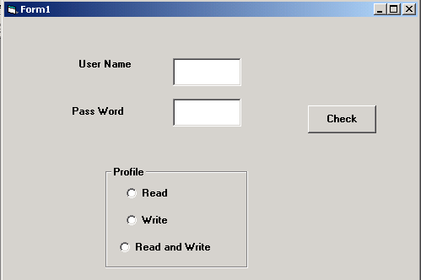

- Develop an Visual Basic application to search an item from list of items using Binary Search

- Develop a Visual Basic Application for Queue Operations.

- Develop a Visual Basic Application for Stack Operations.

- Develop a Visual Basic Application for Coping the elements from one list to other list and Vice-versa (Note: No Duplication is allowed in the list).

- Develop a Visual Basic Application to make survey on different age groups.

Example:
Age groups may be (25-34), (35-44), (45-54) and >=55 and
display the no of people on a particular age group.

- Develop an Calculator by using Visual Basic Application

- Develop a Visual Basic Application to sort the list of numbers.

- Develop an Visual Basic Application to read and print address of a person (Use Input Box)

- Develop an Application form, which abstracts the user profile consisting of Skills regarding OS, Databases, Web technologies, Programming Languages and Experience Details. (Use Combo Boxes for Skill Reading, one can choose more skill as per a skill category, but there is a restriction, i.e. he can opt maximum of three)

- Develop a Visual Basic Application to generate Electricity Bill.

- Develop a program that generates a form the string “ABCDE”

A
BCB
CDEDC

- Develop a Visual Basic Application, which develops a Student Mark List.
Conditions:
  - Read any 5 Subject Marks.
  - For Qualifying, minimum marks are 40%
  - For Pass average is 50%
  - For First Class Percentage is >=60
  - For Second Class Percentage is between 40 and 59
  - For Third Class Percentage is 40
  - Minimum percentage is <50 then Result is Fail.

- Develop a Visual Basic Program to simulate the traffic signals, by using following conditions

  - Form consists of three signals REG, YELLOW and GREEN in an order of column wise.
  - Form consists of one timer label, to display the Time out of the signal.
  - While transforming the signal from REG to Green, signal travel to YELLOW signal.
  - Time out for RED signal is 180 seconds.
  - Time out for Green signal is 120 seconds.
  - Time out for YELLOW signal is 60 seconds.

- Develop a Visual Basic Application to implement the Key Events by using following specifications and conditions.

Control Name | Specifications | Conditions
Labels (Seven) | Having corresponding Captions
Text Box | To Represent the Name of the student | Should not be null, Number.
Five Subject Text Box | To represent the five subject marks | Should not be Null,  Negative, String.
Text Box | To represent the Total of Subjects
Two Command Buttons | One for Calculating the subject totals  Another for clearing the form control values
Note: All the active controls of the form should navigate through the Key events like Key Press, Lost Focus, Got Focus

- Develop an Visual Basic application, which demonstrate the menu Operations.

- Develop an Visual Basic application to demonstrate the MDI forms.

- Develop an Visual Basic Application to perform on-line
examination. (Use Database)

19.Develop an Visual Basic Application to make following
database operations by using Employee Database.

- Inserting the Employee Details.
- Deleting the Employee Details.
- Modifying the employee Details.
- Finding an Employee.

20. Develop an Visual Basic Application with following
specifications and conditions.

  - Application represents two types of users called

    - Administrative Users: Having profile “A”
    - Ordinary Users: Having profile other than “A”

  - Profile “A” people can make all operations like
    - Insertion, Deletion, Updating, Finding Records
    - Navigating the Records.
    - Generating the Reports.

  - Profile not “A” can make only

    - Finding the Records
    - Navigating the Records.
    - Generating the Reports.

B.Sc.(Computer Science): III Year
THEORY PAPER – IV
90 hrs
(3 hrs/ week)
(Elective – 3)
Operating Systems

Unit – 1 : OS Fundamentals and Structure of OS. 18 hrs

Introduction – What Operating Systems do – Computer – system organization – Computer System Architecture – Operating Systems structure – Operating System operations : Process management - Memory management, storage management, Protection and security – Distributed systems – Computing environments.

System structures – Operating System services – User Operating System interface – system calls – Types of system calls – system programs – Operating system structure – system Boot. Process concept – Process scheduling – Operations on processes – Inter process communication – Examples of IPC systems – Communication in Client server systems.

Unit – 2 : Multithreading and Process Synchronization. 18 hrs

Multithreaded programming – Multithreading models – Thread Libraries – Threading issues – Operating System examples. Process Scheduling –Basic concepts – Scheduling Criteria – Scheduling Algorithms – Multiple process scheduling – Thread scheduling – Operating System examples. Process Synchronization – The Critical section problem – Peter’s solution – Synchronization Hardware – Semaphores – Classic problems of Synchronization – Monitors – Synchronization examples. Deadlocks – System model – Deadlock Characterization – Methods for Handling Deadlocks – Deadlock prevention – Deadlock Avoidance – Deadlock Detection – Recovery from Deadlock.

Unit-3 : Memory Management Strategies. 18 hrs

Memory – management strategies – swapping – contiguous Memory allocation – paging – structure of the page table – Segmentation. Virtual – Memory management – Demand paying – Page Replacement. File system – File concept – Access Methods – Directory structure – Protection.

Unit-4 : File Systems and I/O Management. 18 hrs

Implementing file systems –File system structure File system implementation – Directory implementation – Allocation methods – Free space management – Efficiency and Performance – Recovery. Secondary storage structure – overview of Mass-storage structure-Disk structure - Disk Attachment – Disk Scheduling – Disk Management – Swap space Management – RAID structure. I/O systems – overview – I/O hardware – Application I/O interface – Kernal I/O subsystem – Transforming I/O requests to Hardware Operations.

Unit – 5 : Real Time Systems and Case Study. 18 hrs

Real Time systems – Overview – System characteristics – Features of Real time Kernels – Implementing Real time Operating Systems – Real time CPU Scheduling – Vx works 5.x Case study : The Linux System : Linux history – Design principles – Kernel Modules – Process Management – Scheduling – Memory Management – File systems – Input and Output – Inter process communication – Network structure.

Prescribed Book :

- Abraham Silberschatz, Peter Baer Galvin, Greg Gagne, Operating System Principles, Seventh Edition, Wiley India Edition (2007) Chapters (1 to 13, 19, 21)

Reference Books :

- William Stallings, Operating Systems Internals and Design
Principles, Fifth Edition, Pearson Education (2007).

2. Andrew S Tanenbaum, Modern Operating Systems, 2nd Edition,
Pearson Education.

3. Archer Harris J, Operating Systems, Schaum outline series,
Tata McGraw Hill(2006).

4. Davis and Rajkumar, Operating Systems A Systematic view,
Sixth Edition, Pearson Education (2007).

5. Bhatt, Introduction to Operating Systems: Concepts and Practice,
2nd Edition, PHI (2008).

6. Stallings, Operating Systems - Internals and Design Principles,
5th Edition, PHI (2007).
B.Sc(Computer Science): III Year
PRACTICAL PAPER – IV
90 hrs
(3 hrs/ week)
(Elective – 3)
Operating Systems Lab

LAB CYCLE

1. Write a shell script to accept two numbers and perform all arithmetic operations on it.

2. Write a shell script to find largest of three numbers using conditional execution operators

3. Write a shell script to accept the name of the file from standard input and perform the following
tests on it
- File executable
- File readable
- File writable
- Both readable & writable

4.Write a shell script which will display the username and terminal name who login recently in to the
Unix system.

5.Write a shell script to find number of files in a directory

6.Write a shell script to print the following format
1
12
123
1234
……….

7. Write a shell script which will display the number of days in the given month and year

8. Write a shell script to check whether a given number is perfect number or not

9. Write a shell script for concatenation of two strings using arguments

10. Write a shell script to demonstrate break and continue statements

11. Write a shell script to satisfy the following menu options
- Display current directory path
- Display today’s date
- Display users who are connected to the Unix system
- Quit

12. Write a shell script to delete all files whose size is zero bytes from current directory

13. Write a shell script to display reverse numbers from given argument list

14. Write a shell script to display factorial value from given argument list

15. Write a shell script which will greet you “Good Morning”, “Good Afternoon”, “Good Evening”

and “Good Night” according to current time

16. To implement the FCFS Algorithm

17. To implement the Shortest Job First Algorithm

18. To implement Priority Algorithm

19. To implement the round robin Algorithm

20. To implement the FIFO page replacement Algorithm

21. To implement LRU page replacement Algorithm

22. To implement Resource Request Algorithm

23. To implement First-Fit, Best-Fit, Worst-Fit Algorithm

24. To implement Sequential File Organization

25. To implement Random File Organization

* * * * *

B.Sc.(Computer Science): III Year
THEORY PAPER – IV
90 hrs
(3 hrs/ week)
(Elective – 4)
PHP, MySQL and Apache

Unit-1 : Installing and Configuring MySQL, Apache and PHP 18 hrs

Installing and Configuring MySQL: Current and Future Versions of MySQl, How to Get MySQL, Installing MySQL on Linux, Windows, Trouble Shooting your Installation, Basic Security Guidelines, Introducing MySQL Privilege System, Working with User Privileges.

Installing and Configuring Apache: Current and future versions of Apache, Choosing the Appropriate Installation Method, Installing Apache on Linux, Windows, Apache Configuration File Structure, Apache Log Files, Apache Related Commands, Trouble Shooting.

Installing and Configuring PHP: Building PHP on Linux with Apache, Windows, php.ini.Basics, The Basics of PHP scripts.

(Chapters: 2,3,4)

Unit-2 : PHP Basics 18 hrs

The Building blocks of PHP: Variables, Data Types, Operators and Expressions, Constants.

Flow Control Functions in PHP: Switching Flow, Loops, Code Blocks and Browser Output.

Working with Functions: What is function?, Calling functions, Defining Functions, Returning the values from User-Defined Functions, Variable Scope, Saving state between Function calls with the static statement, more about arguments.

Working with Arrays: What are Arrays?, Creating Arrays, Some Array-Related Functions.

(Chapters: 5,6,7,8)

Unit-3 : Working with Objects and Forms 18 hrs

Working with Objects: Creating Objects, Object Instance

Working with Strings, Dates and Time: Formatting strings with PHP, Investigating Strings with PHP, Manipulating Strings with PHP, Using Date and Time Functions in PHP.

Working with Forms: Creating Forms, Accessing Form Input with User defined Arrays, Combining HTML and PHP code on a single Page, Using Hidden Fields to save state, Redirecting the user, Sending Mail on Form Submission, Working with File Uploads.

(Chapters: 9,10,11)

Unit-4 : Introduction to Cookies, Working with Files, Directories and Images. 18 hrs

Working with Cookies and User Sessions: Introducing Cookies, Setting a Cookie with PHP, Session Function Overview, Starting a Session, Working with session variables, passing session IDs in the Query String, Destroying Sessions and Unsetting Variables, Using Sessions in an Environment with Registered Users.

Working with Files and Directories: Including Files with inclue(), Validating Files, Creating and Deleting Files, Opening a File for Writing, Reading or Appending, Reading from Files, Writing or Appending to a File, Working with Directories, Open Pipes to and from Process Using popen(), Running Commands with exec(), Running Commands with system() or passthru().

Working with Images: Understanding the Image-Creation Process, Necessary Modifications to PHP, Drawing a New Image, Getting Fancy with Pie Charts, Modifying Existing Images, Image Creation from User Input.

(Chapters:12,13,14)

Unit-5 : Introduction to MySQL and Interfacing with Databases through PHP 18 hrs

Understanding the database design process: The Importance of Good Database Design, Types of Table Relationships, Understanding Normalization.

Learning basic SQL Commands: Learning the MySQL Data types, Learning the Table Creation Syntax, Using Insert Command, Using SELECT Command, Using WHERE in your Queries, Selecting from Multiple Tables, Using the UPDATE command to modify records, Using RELACE Command, Using the DELETE Command, Frequently used string functions in MySQL, Using Date and Time Functions in MySQL.

Using Transaction and stored procedures in MySQL: What is Transaction?, What are Stored Procedures?

Interacting with MySQL using PHP: MySQL Versus MySQLi Functions, Connecting to MySQL with PHP, Working with MySQL Data

Creating an Online Address Book: Planning and Creating Database Tables, Creating Menu, Creating Record Addition Mechanism, Viewing Records, Creating the Record Deletion Mechanism, Adding Sub-entities to a Record.
(Chapters: 15,16,17,18,20)

Prescribed Book:
- Julie C. Meloni, PHP MySQL and Apache, SAMS Teach yourself, Pearson Education (2007).
Reference Book:
  - Xue Bai Michael Ekedahl, The web warrior guide to Web Programming, Thomson (2006).

B.Sc(Computer Science): III Year

PRACTICAL PAPER – IV
90 hrs
(3 hrs/ week)
(Elective – 4)
PHP and MySQL Lab

MySQL Lab Cycle

Cycle -1

An Enterprise wishes to maintain the details about his suppliers and other corresponding details. For that he uses the following details.

Suppliers (sid: Integer, sname: string, address: string)
Parts (pid: Integer, pname: string, color: string)
Catalog (sid: integer, pid: integer, cost: real)

The catalog relation lists the prices charged for parts by suppliers.

Write the following queries in SQL:

- Find the pnames of parts for which there is some supplier.
- Find the snames of suppliers who supply every part.
- Find the snames of supplier who supply every red part.
- Find the pnames of parts supplied by London Supplier abd by no one else.
- Find the sid’s of suppliers who charge more for some part than the average cost of that part.
- For each part, find the sname of the supplier who charges the most for that part.
- Find the sid’s of suppliers who supply only red parts.
- Find the sid’s of suppliers who supply a red and a green part.
- Find the sid’s of suppliers who supply a red or green part.
- Find the total amount has to pay for that suppler by part located from London.

Cycle – 2

An organisation wishes to maintain the status about the working hours made by his employees. For that he uses the following tables.

Emp (eid: integer, ename: string, age: integer, salary: real)
Works (eid: integer, did: integer, pct_time: integer)
Dept (did: integer, budget: real, managerid: integer)

An employee can work in more than one department; the pct_time field of the works relation shows the percentage of time that a given employee works in a given department.

Resolve the following queries.

- Print the names and ages of each employee who works in both Hardware and Software departments.
- For each department with more than 20 full time equivalent employees (i.e., where the part-time and full-time employees add up to at least that many full-time employees), print the did’s together with the number of employees that work in that department.
- Print the name of each employee whose salary exceeds the budget of all of the departments that he or she work in.
- Find the managerid’s of managers who manage only departments with budgets greater than 1,000,000.
- Find the enames of managers who manage the departments with largest budget.
- If a manager manages more than one department, he or she controls the sum of all the budgets for those departments. Find the managerid’s of managers who control more than 5,000,000.
- Find the managerid’s of managers who control the highest amount.
- Find the average manager salary.

PHP Lab Cycle

- Write a PHP program to Display “Hello”
- Write a PHP Program to display the today’s date.
- Write a PHP Program to read the employee details.
- Write a PHP Program to display the
- Write a PHP program to prepare the student marks list.
- Write a PHP program to generate the multiplication of two matrices.
- Write a PHP Application to perform demonstrate the college website.
- Write a PHP application to add new Rows in a Table.
- Write a PHP application to modify the Rows in a Table.
- Write a PHP application to delete the Rows from a Table.
- Write a PHP application to fetch the Rows in a Table.
- Develop an PHP application to make following Operations
  - Registration of Users.
  - Insert the details of the Users.
  - Modify the Details.
  - Transaction Maintenance.
    - No of times Logged in
    - Time Spent on each login.
    - Restrict the user for three trials only.
    - Delete the user if he spent more than 100 Hrs of transaction.

